- Surface Area of Solids

1. A swimming pool water surface measures 10m long and 8m wide. A path of uniform width is made all round the swimming pool. The total area of the water surface and the path is 168m²
(a) Find the width of the path (4 mks)
(b) The path is to be covered with square concrete slabs. Each corner of the path is covered with a slab whose side is equal to the width of the path. The rest of the path is covered with slabs of side 50cm. The cost of making each corner slab is sh 600 while the cost of making each smaller slab is sh.50. Calculate
(i) The number of the smaller slabs used (4 mks)
(ii) The total cost of the slabs used to cover the whole path (2 mks)
2. The figure below shows a solid regular tetrapack of sides 4cm.
(a) Draw a labelled net of the solid. (1mk)
(b) Find the surface area of the solid. (2mks)
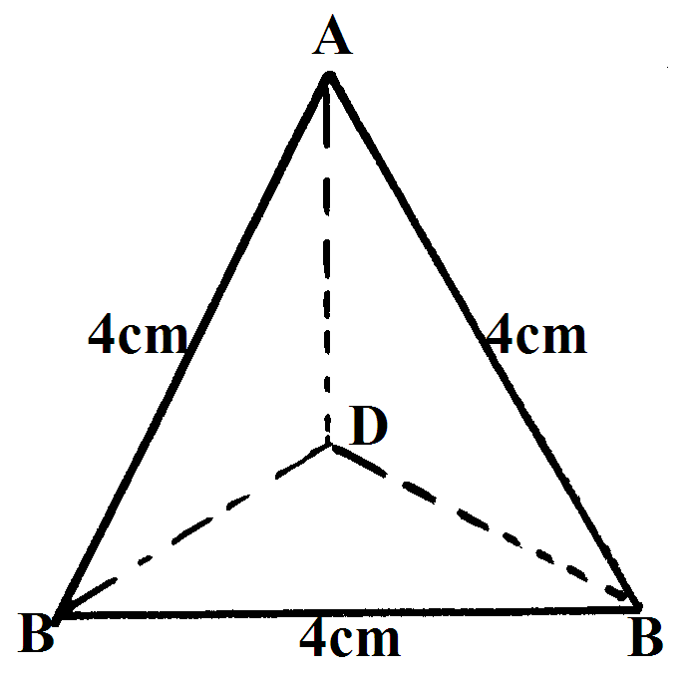
3. The diagram shows a right glass prism ABCDEF with dimensions as shown.
14.7cm
7.4 cm
5.2cm
5.2cm
A
B
C
D
E
F

Calculate:
(a) the perimeter of the prism (2 mks)
(b) The total surface area of the prism (3 mks)
(c) The volume of the prism (2 mks)
(d) The angle between the planes AFED and BCEF (3 mks)
4. The base of a rectangular tank is 3.2m by 2.8m. Its height is 2.4m. It contains water to a depth of 1.8m. Calculate the surface area inside the tank that is not in contact with water. (2mks)
5. Draw the net of the solid below and calculate surface area of its faces (3mks)
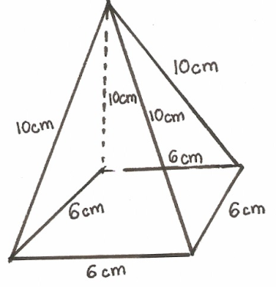

6. E

F D
C
4cm
8cm
A
5cm B
The figure above is a triangular prism of uniform cross-section in which AF = 4cm, AB = 5cm and BC = 8cm.
(a) If angle BAF = 30⁰, calculate the surface area of the prism. (3 marks)
(b) Draw a clearly labeled net of the prisms. (1 mark)
7. Mrs. Dawati decided to open a confectionary shop at corner Baridi. She decorated its entrance with 10 models of cone ice cream, five on each side of the door. The model has the following shape and dimensions. Using π = 3.142 and calculations to 4 d.p.
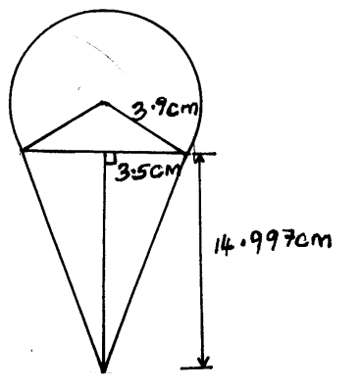
(a) Calculate the surface area of the conical part. (2mks)
(b) Calculate the surface area of the top surface. (4mks)
(c) Find total surface area of one model. (2mks)
(d) If painting 5cm² cost ksh 12.65, find the total cost of painting the models (answer to 1 s.f). (2mks)
8. A right pyramid of height 10cm stands on a square base ABCD of side 6 cm.
a) Draw the net of the pyramid in the space provided below. (2mks)
b) Calculate:-
(i) The perpendicular distance from the vertex to the side AB. (2mks)
(ii) The total surface area of the pyramid. (4mks)
c) Calculated the volume of the pyramid. (2mks)
9. The figure below shows a solid object consisting of three parts. A conical part of radius 2 cm and slant height 3.5 cm a cylindrical part of height 4 cm. A hemispherical part of radius 3 cm . the cylinder lies at the centre of the hemisphere. (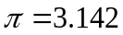)

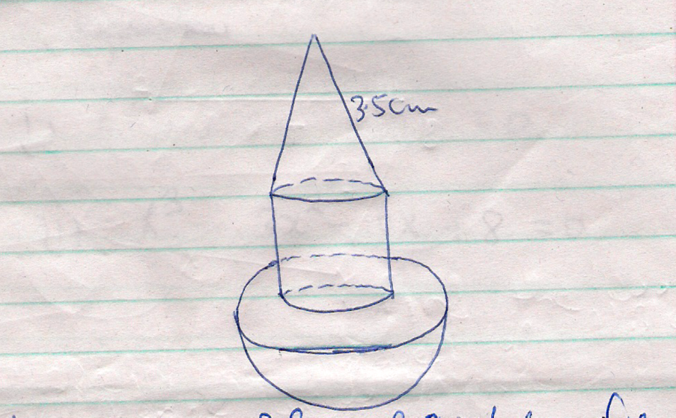

Calculate to four significant figures:
      - The surface area of the solid (5 marks)
      - The volume of the solid (5 marks)
10. A lampshade is in the form of a frustrum of a cone. Its bottom and top diameters are
12cm and 8cm respectively. Its height is 6cm.Find;
(a) The area of the curved surface of the lampshade
(b) The material used for making the lampshade is sold at Kshs.800 per square metre.
Find the cost of ten lampshades if a lampshade is sold at twice the cost of the material
11. A cylindrical piece of wood of radius 4.2cm and length 150cm is cut lengthwise into two
equal pieces. Calculate the surface area of one piece

12. The base of an open rectangular tank is 3.2m by 2.8m. Its height is 2.4m. It contains water
to a depth of 1.8m. Calculate the surface area inside the tank that is not in contact with water

13. The figure below represents a model of a solid structure in the shape of frustrum of a cone with a
hemisphere top. The diameter of the hemispherical part is 70cm and is equal to the diameter of the
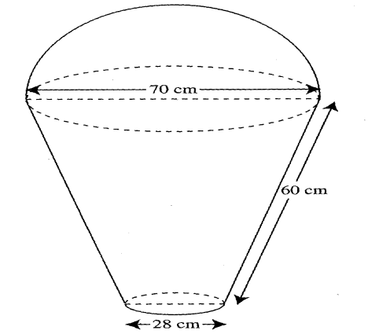
top of the frustrum. The frustrum has a base diameter of 28cm and slant height of 60cm.

Calculate :
(a) the area of the hemispherical surface
(b) the slant height of cone from which the frustrum was cut
(c) the surface area of frustrum
(d) the area of the base
(e) the total surface area of the model

14. A room is 6.8m long, 4.2m wide and 3.5m high. The room has two glass doors each measuring
75cm by 2.5m and a glass window measuring 400cm by 1.25m. The walls are to be painted
except the window and doors.
a) Find the total area of the four walls
b) Find the area of the walls to be painted
c) Paint A costs Shs.80 per litre and paint B costs Shs.35 per litre. 0.8 litres of A covers an area
of 1m² while 0.5m² uses 1 litre of paint B. If two coats of each paint are to be applied. Find
the cost of painting the walls using:
i) Paint A
ii) Paint B
d) If paint A is packed in 400ml tins and paint B in 1.25litres tins, find the least number of tins
of each type of paint that must be bought.

15. The figure below shows a solid frustrum of pyramid with a square top of side 8cm and
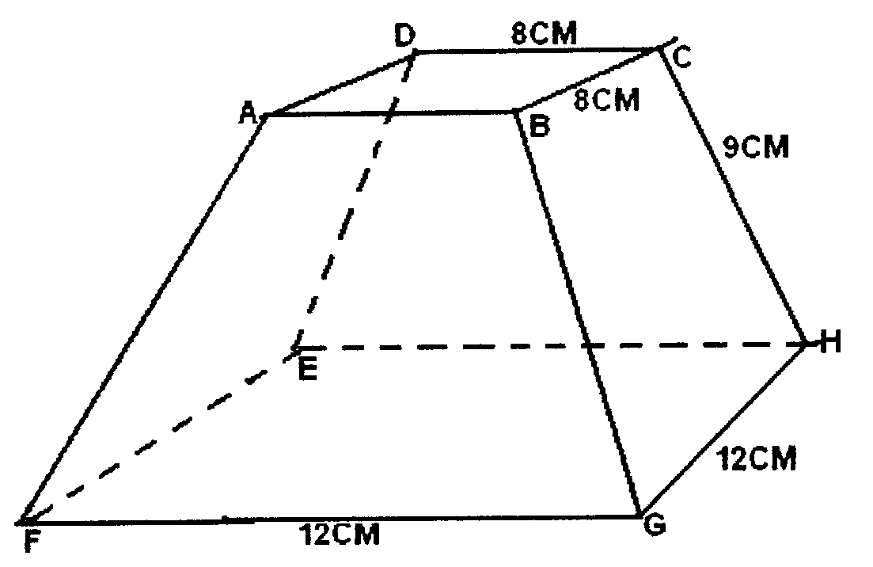
a square base of side 12cm. The slant edge of the frustrum is 9cm

Calculate:
- the total surface area of the frustrum
(b) the volume of the solid frustrum
(c) the angle between the planes BCHG and the base EFGH.

